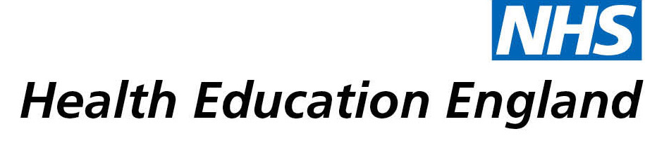

# Library and Knowledge Services case study

# *RBFT Library & Knowledge Services: Providing evidence for suspected child abuse cases*

Date: *8 March 2021*

## Reason for enquiry

A consultant radiologist was *“asked to review a CT head scan from an infant with an unusual anatomical feature that had caused some diagnostic confusion; there was concern that it could be a fracture which would have significant child protection consequences.”*

## What the knowledge and library specialist did

The consultant emailed the RBFT Library and Knowledge Services to ask for full access to three articles in order to do research for this case. The library was able to find the articles which they sent to the consultant within 5 hours. One of these articles described the findings that matched the case they were consulting on.

# Impact of input from the library and knowledge service

By responding quickly and being able to procure multiple articles, within which one of the articles requested described the findings, the library helped the consultant to confirm their suspicions that it wasn’t a fracture or a possible case of child abuse.

## Immediate Impact

*“Fortunately, I was able to find a journal article that described the findings. Katie managed to serve the article with a very quick turnaround, which allowed me to demonstrate to my clinical colleagues that my interpretation of the feature as an anatomical variant (as opposed to a fracture) was valid. This provided for a great deal of reassurance (and relief) for the paediatricians and parents alike.”*

## Submission by:

*Dr Kieran Hogarth, Consultant Neuroradiologist, Royal Berkshire NHS Foundation Trust*

*Katie Wise, Library Assistant, Royal Berkshire NHS Foundation Trust*

## For further information on how you can get similar support contact your local NHS library and knowledge service.